**Exercises about OS installation.**

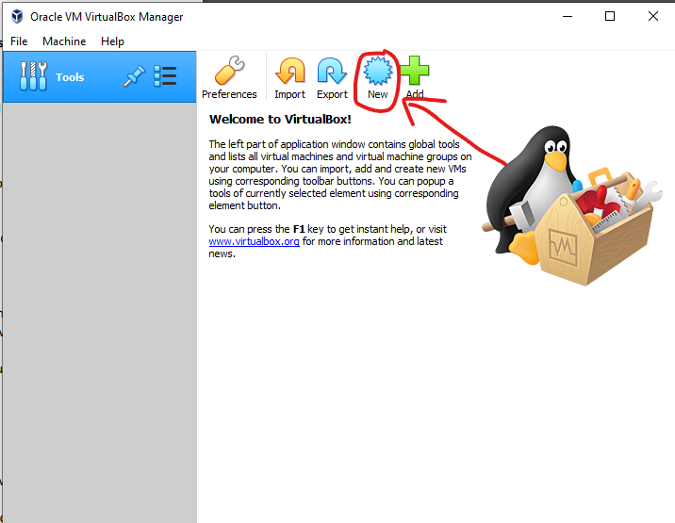

We click on “New” in the Virtual Box Manager main screen. We can also click on Machine (top left ) and then click New there.

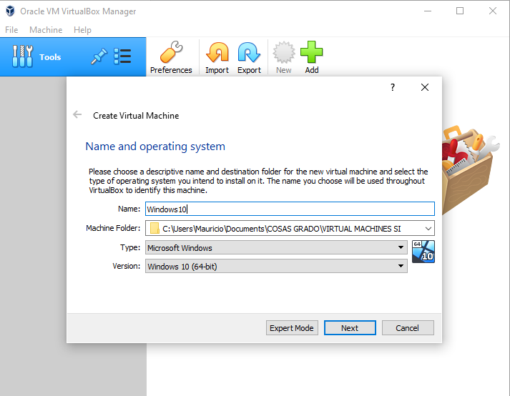

Then we choose the name, the folder where it will go and the OS itself. In this case, we are using Windows 10 64 bit. And click next.

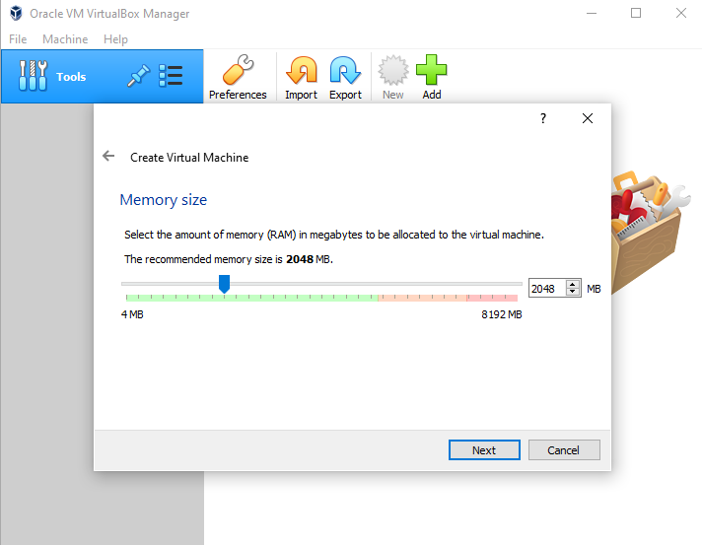

Afterwards, we must choose the memory size (RAM), we will use 2048 or 2 GB of RAM for this exercise. Then we hit next.

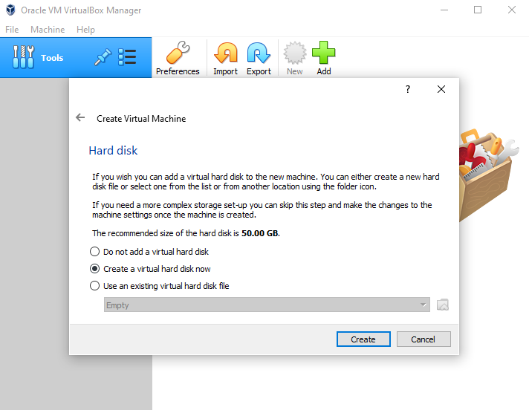

Then we choose the Hard disk. We will leave this option as is. And click create.

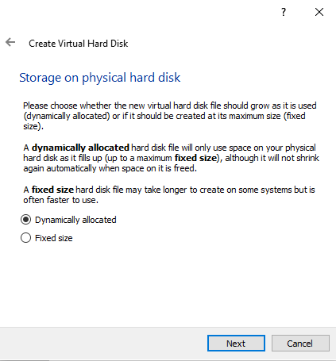

Then we will choose if the main hard disk has a fixed or dynamically alocated size, I chose to have this hard drive be dinamically allocated and 50 GB.

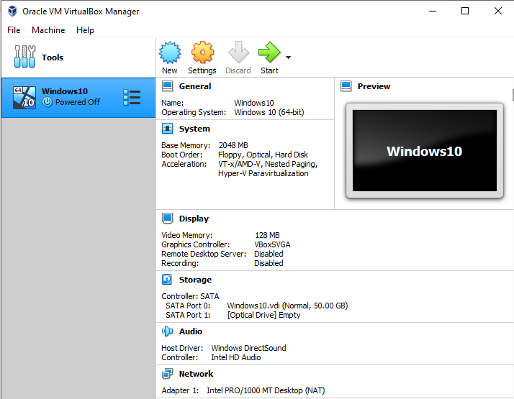

On this screen we will choose “Settings” and go to “Storage”.

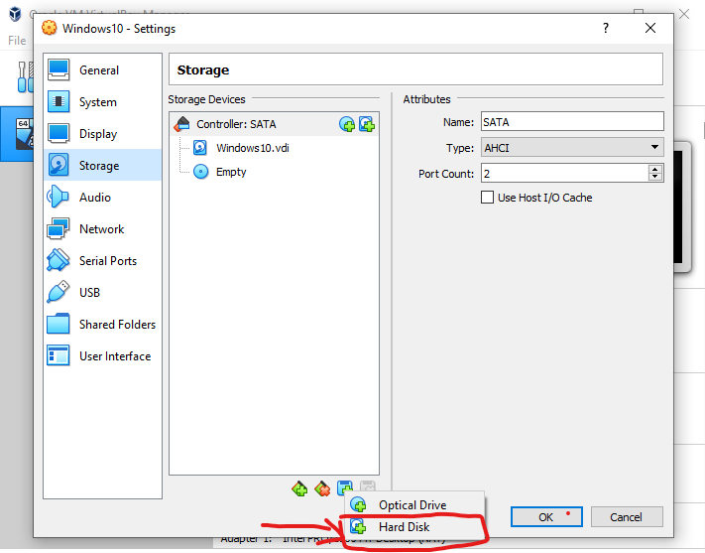

Then we click the new Storage unit button thats under the storage devices screen and we choose hard disk, we then create a new Fixed size hard disk with 30 GB of capacity.

**2.**

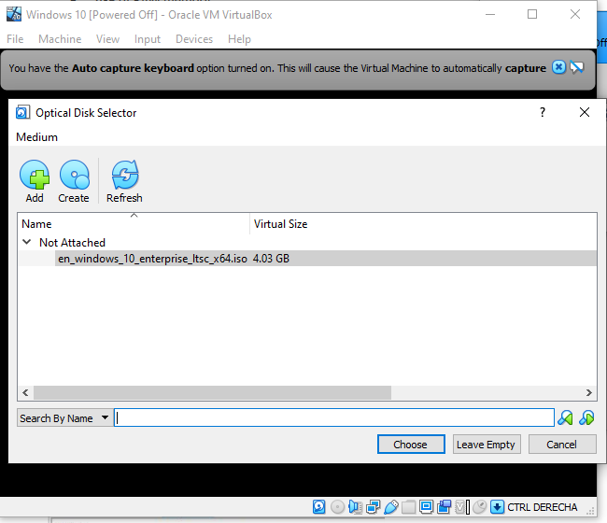

To install windows we add the ISO of the OS ( in our case Windows 10 64 bit) and click Choose, then Start. Then we proceed with the installation.

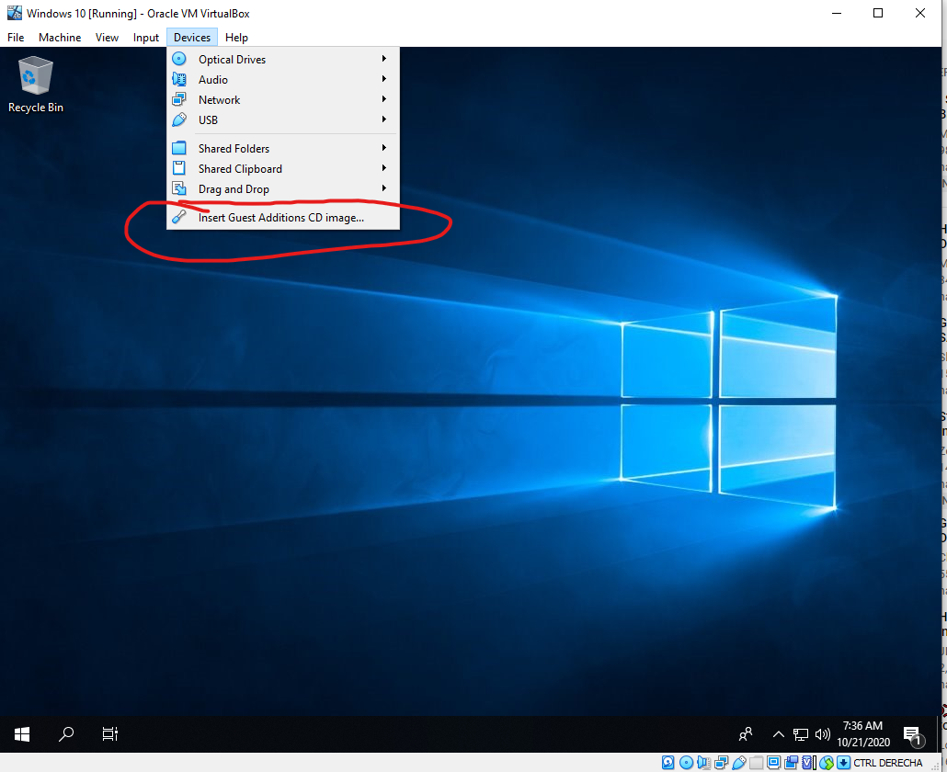

After the installation is complete, we click devices and click on Insert guest additions.

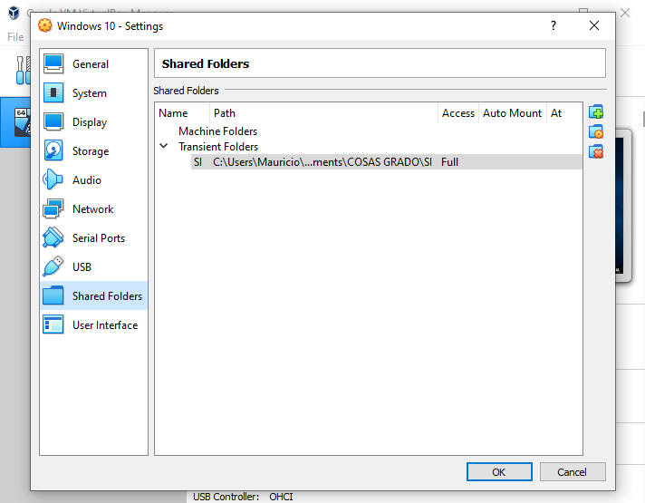

To add shared folders we go to the machine settings and add a new shared directory. As seen in the image.

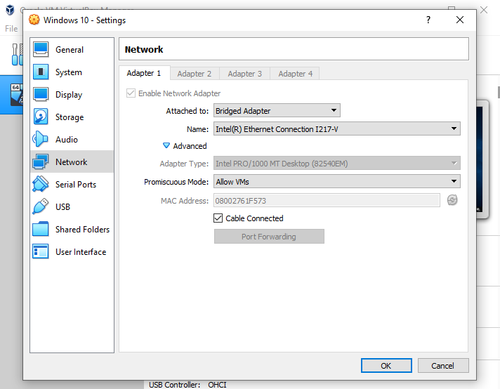

Then on network settings we select these settings.

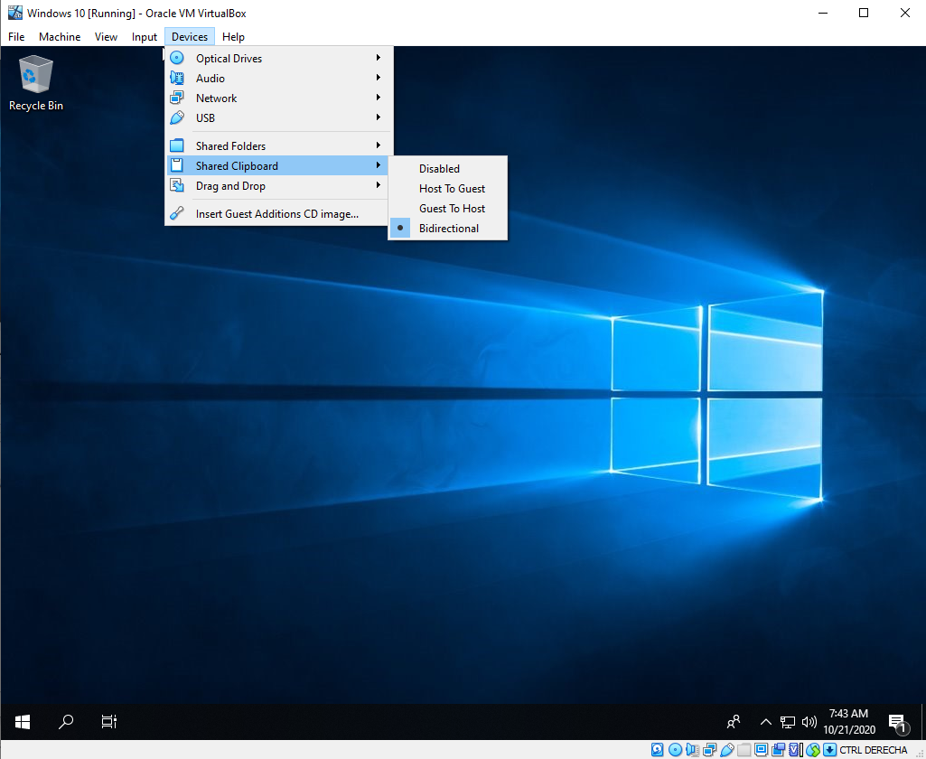

In order to have the shared clipboard, we just go to the Devices tab on the machine, then go to Shared Clipboard and set it as bidirectional.

**3.**

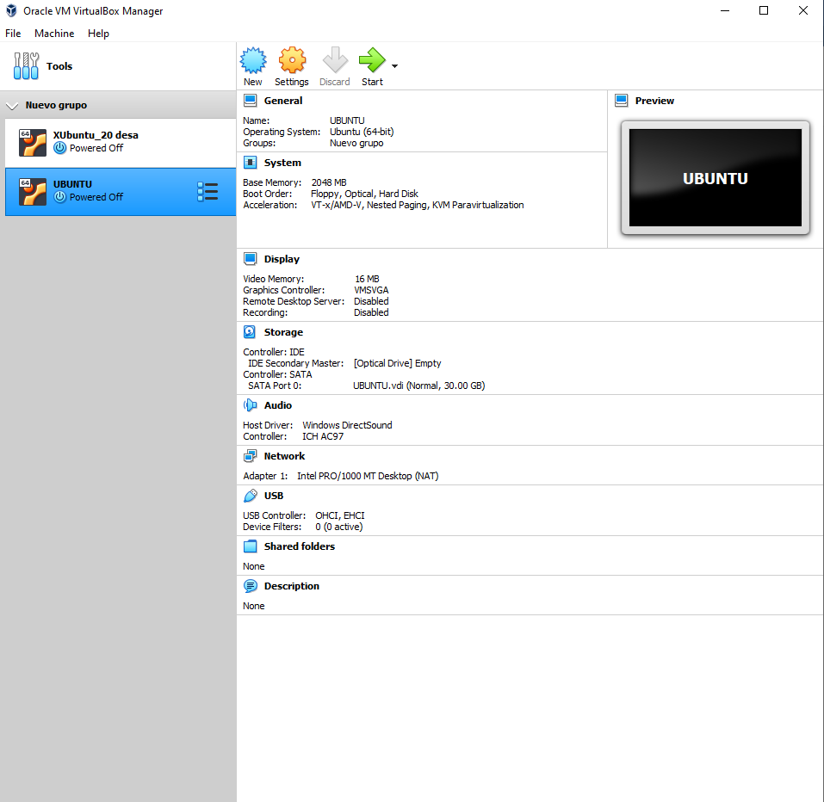

We created the new Ubuntu VM, with 2 GB RAM and a 30 GB Hard Drive.

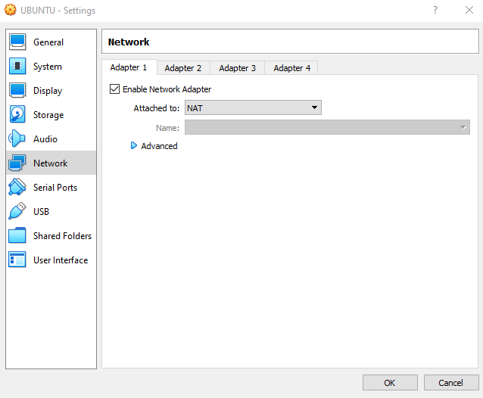

In order to have access to an internet connection, weo go to Network settings and select the NAT option.

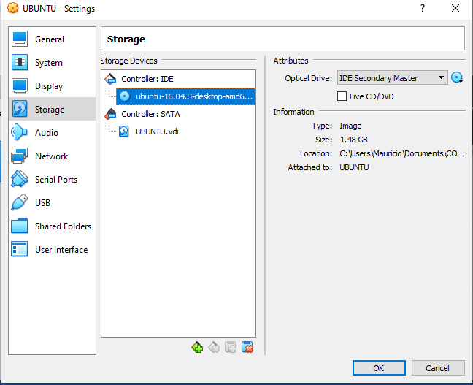

In order to select the OS, we can also go to the Storage tab, and introduce the OS directly into the empty Optical Drive. Then we proceed with the installation.

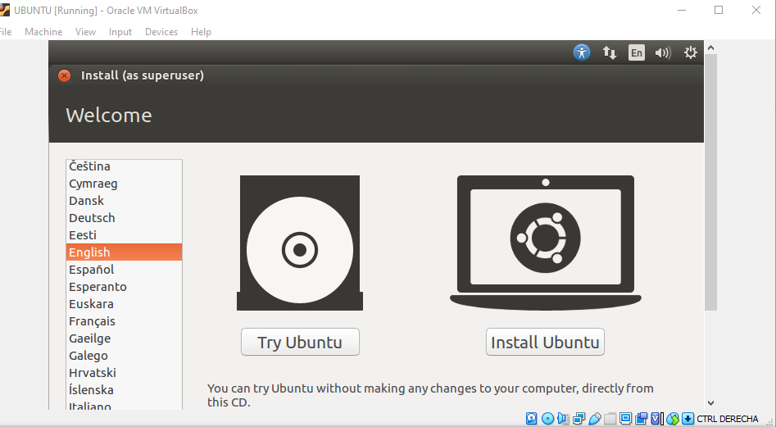

We select the language and click on install, then we are asked if we want to download updates, continue without checking the box.

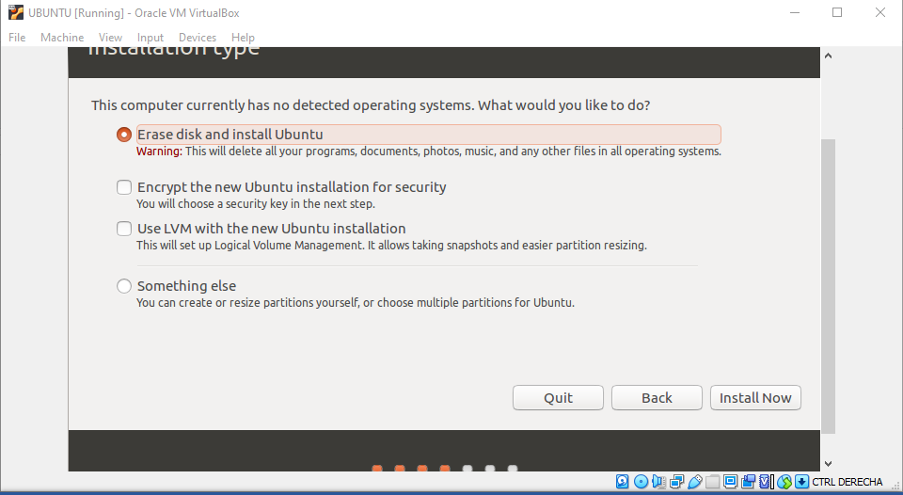

We then are asked to choose the installation type. We wll choose our partitions ourselves, so we click “Something else” . On the partition screen, we will click on “New Partition Table” and then double-click on free space.

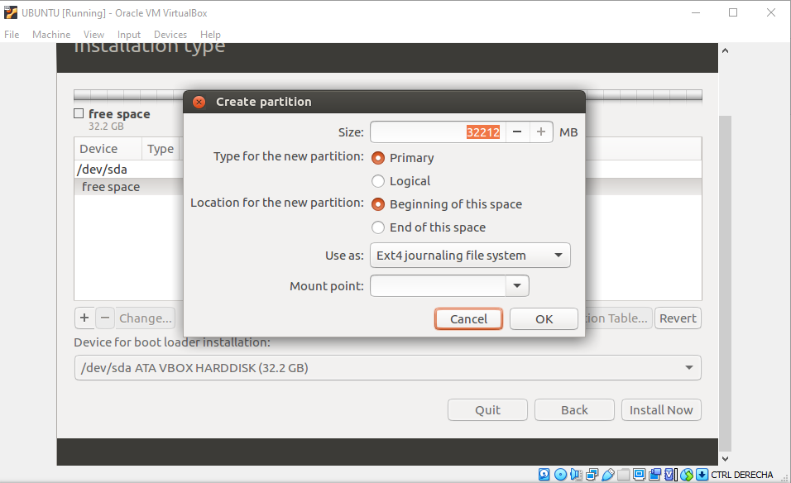

We establish 1024 MB as the size of this partition. And then in the Mount point we will write: /boot. The other options will remain being the default.

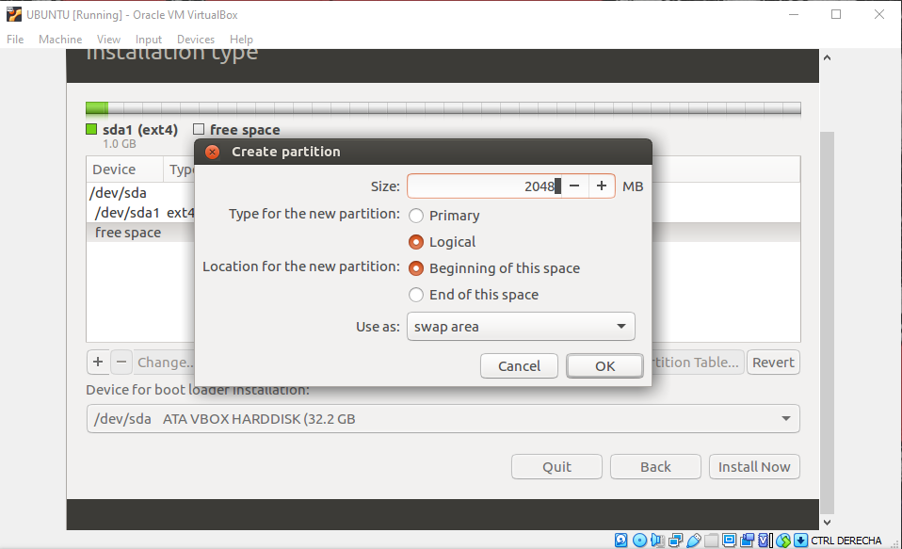

These are the parameters of the next partition, the swap partition.

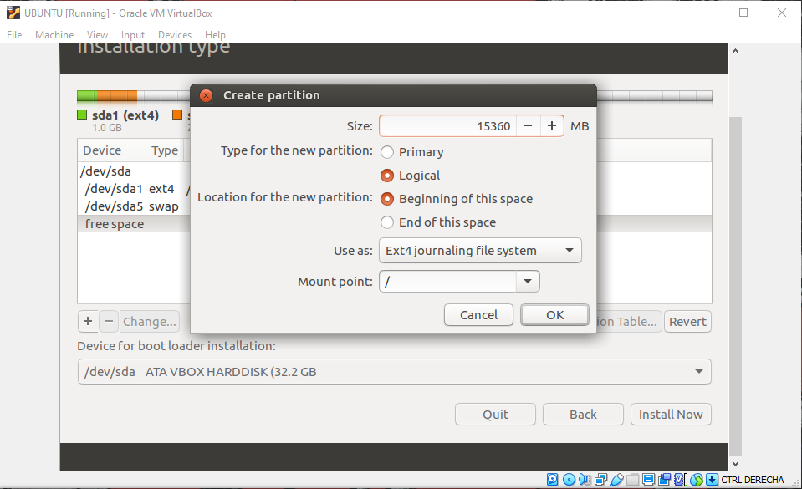

This is the next partition. The next partition will be 11689 MB and it´s the /home. Then we click install. We choose the location, the language and we pick a username and password.

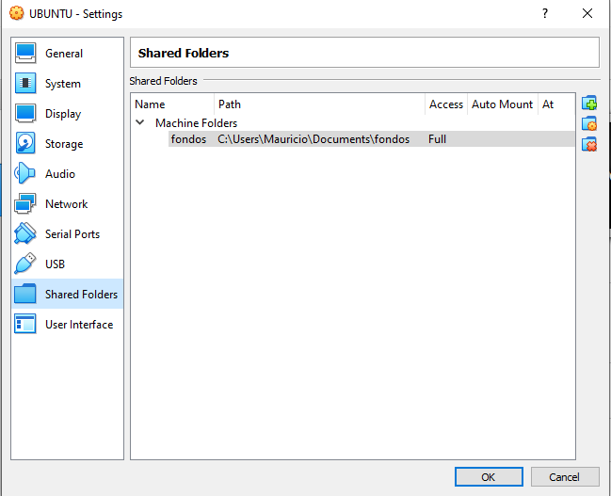

In order to make a shared folder, we go to the UBUNTU VM settings, go to shared folders and add a new folder with the icon on the top right.

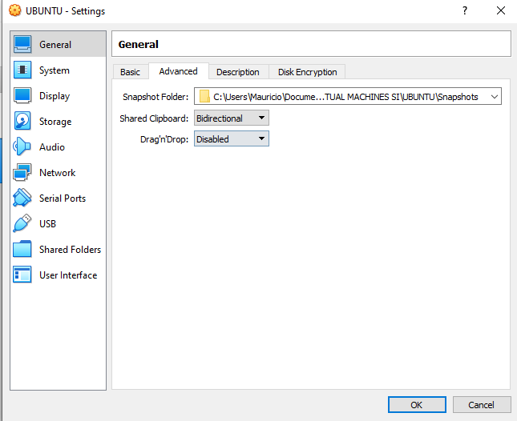

In order to have a shared clipboard, we go to the general tab and in advanced, we choose bidirectional in the Shared Clipboard option.